

| CALCIUM WHEELS
Over ninety-percent of the calcium in the body is stored in the bones and teeth, which act as reservoirs in which the calcium can be withdrawn as required for extra-skeletal functions. Calcium is found in virtually every cell throughout the body and is considered a biological messenger responsible for carrying signals to target activities with cells through specific calcium channels.
Calcium is regulated in tissues and serum at the expense of skeletal structures. It is regulated by the parathyroid, and kidneys and is affected by insulin, adrenal, as well as male and female hormones. An imbalance of calcium relative to its synergistic and antagonistic nutrients can be a major contributor to osteoporosis even with adequate dietary calcium intake.

The following graphics illustrate some of calcium’s biological antagonistic relationships (arrows indicate antagonistic effect). In the case of excessive tissue calcium, increased intake of these antagonistic vitamins and nutritional minerals may be of benefit. However, prolonged intake of these specific vitamins and/or minerals, singularly or in combination, can produce a calcium deficiency, especially if the nutritional or tissue calcium status is already marginal. Conversely, excessive calcium or prolonged intake of calcium can antagonize these same specific vitamins and minerals. It should be noted that antagonism with another nutrient can occur via competition on an absorptive level (intestinal absorption) or metabolic level (cellular), producing compartmental displacement, or increasing requirements.
-------------------------------------------------------------------------------------------------------------------------------------------------------

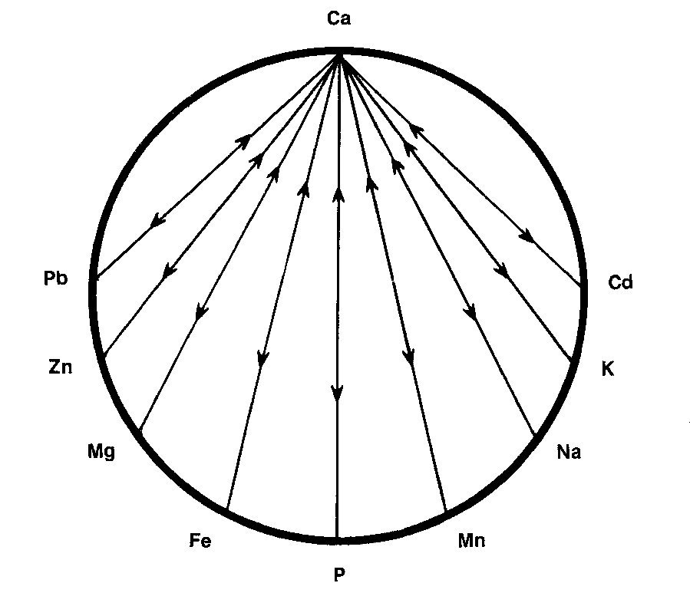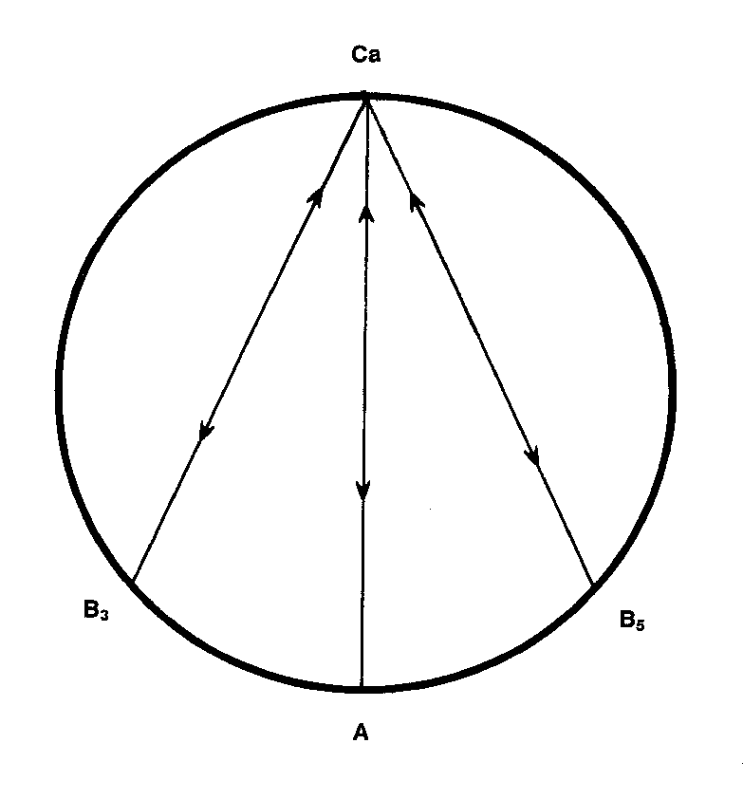

-------------------------------------------------------------------------------------------------------------------------------------------------------
For Further Information, please refer to "The Nutritional Relationships of Calcium, Watts, D.L., Journal Of Orthomolecular Medicine, 5, 2, 1990
Trace Elements has pioneered the recognition of nutritional interrelationships, and specializes in evaluating individual nutritional requirements through hair tissue mineral profiles.

Copyright 1990 | Trace Elements, Inc. | All rights reserved.
No part of this document may be used or reproduced in any manner whatsoever without the express written permission of Trace Elements, Incorporated. 4501 Sunbelt Drive, Addison, Texas 75001 USA (972) 250-6410.

