

| CHROMIUM WHEELS
Chromium is an essential trace mineral, important in processing carbohydrates and fats, and helping cells respond properly to insulin. It is known that chromium is a constituent of the glucose tolerance factor (GTF) and is synergistic with insulin in promoting cellular glucose uptake. Chromium is important for the structure and metabolism of nucleic acids. A number of physiological and disease conditions are related to chromium status.

The following graphics illustrate some of chromium’s biological antagonistic relationships (arrows indicate antagonistic effect). Prolonged intake of these specific vitamins and/or minerals, singularly or in combination, can produce a chromium deficiency, especially if the nutritional or tissue chromium status is already marginal. Conversely, excessive chromium or prolonged intake of chromium can antagonize these same specific vitamins, minerals and heavy metals. It should be noted that antagonism with another nutrient can occur via competition on an absorptive level (intestinal absorption) or metabolic level (cellular), producing compartmental displacement, or increasing requirements. Note: The broken line in this graphic indicates an indirect antagonistic relationship.
-------------------------------------------------------------------------------------------------------------------------------------------------------

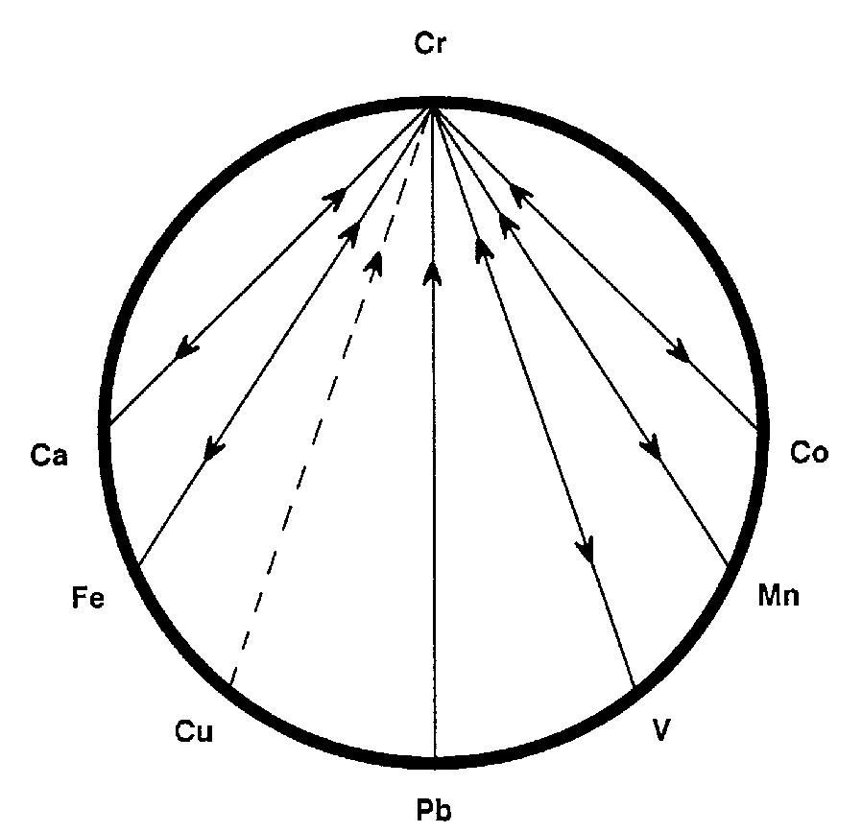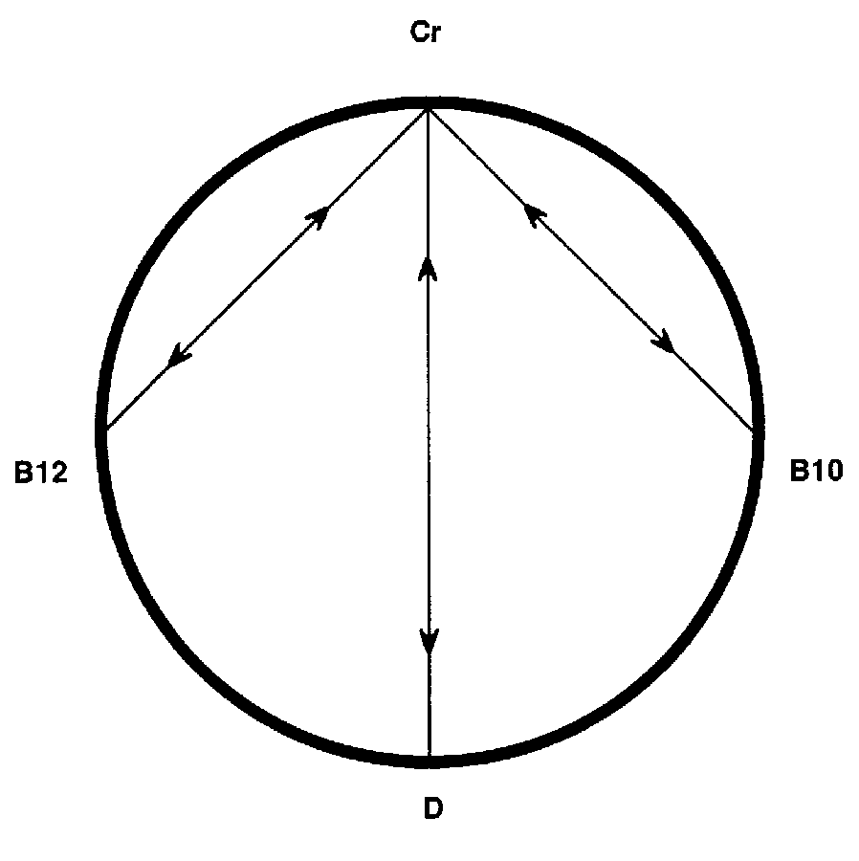

-------------------------------------------------------------------------------------------------------------------------------------------------------
For Further Information, please refer to "The Nutritional Relationships of Chromium, Watts, D.L., Journal Of Orthomolecular Medicine, 4, 1, 1989

Trace Elements has pioneered the recognition of nutritional interrelationships, and specializes in evaluating individual nutritional requirements through hair tissue mineral profiles.

Copyright 1989 | Trace Elements, Inc. | All rights reserved.
No part of this document may be used or reproduced in any manner whatsoever without the express written permission of Trace Elements, Incorporated. 4501 Sunbelt Drive, Addison, Texas 75001 USA (972) 250-6410.

