

| COPPER WHEELS
Copper is a constituent of many enzymes including cytochrome c oxidase, superoxide dismutase, ceruloplasmin, dopamine B-hydroxylase, lysyl oxidase and monoamine oxidase. An imbalance of copper relative to other nutrients can disrupt the activity of these important enzyme functions. In regards to copper status within the body, it should be noted that excess copper is just as serious as copper deficiency.

The following graphics illustrate some of copper’s biological antagonistic relationships (arrows indicate antagonistic effect). In the case of excessive tissue copper burden, increased intake of these antagonistic vitamins and nutritional minerals may be of benefit. However, prolonged intake of these specific vitamins and/or minerals, singularly or in combination, can produce a copper deficiency, especially if the nutritional or tissue copper status is already marginal. Conversely, copper toxicity or prolonged intake of copper can antagonize these same specific vitamins and minerals. It should be noted that antagonism with another nutrient can occur via competition on an absorptive level (intestinal absorption) or metabolic level (cellular), producing compartmental displacement, or increasing requirements.
-------------------------------------------------------------------------------------------------------------------------------------------------------
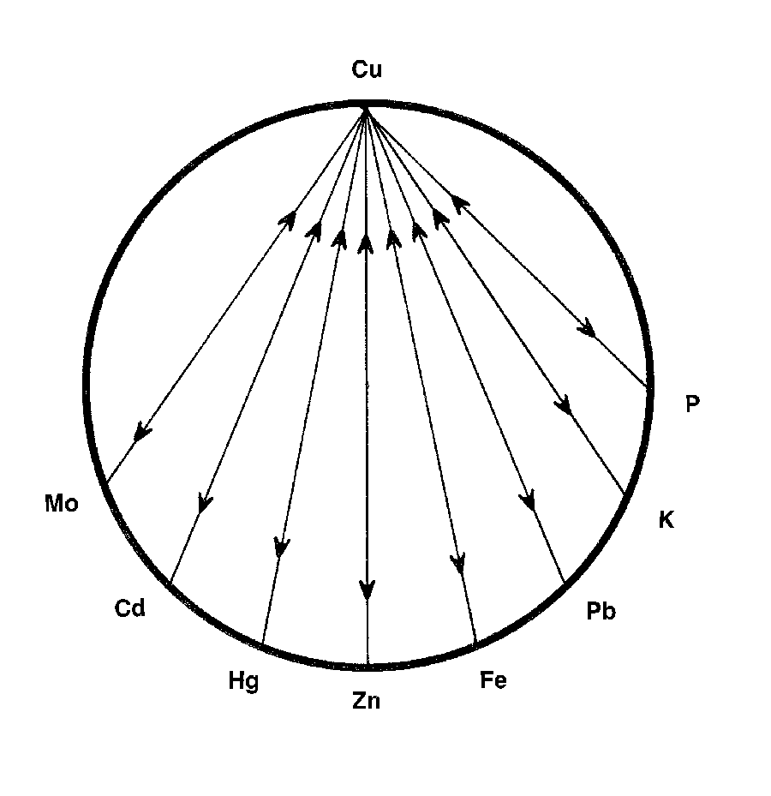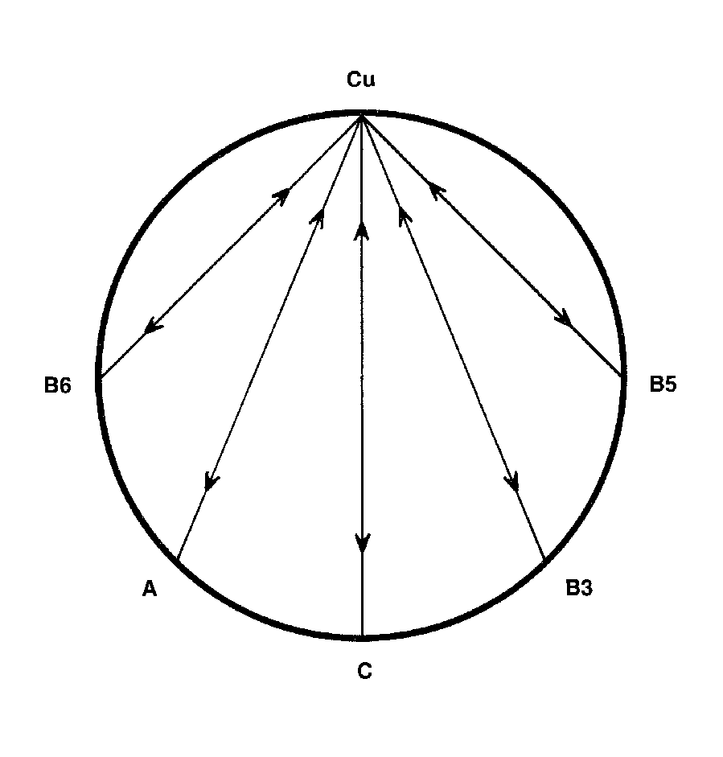
-------------------------------------------------------------------------------------------------------------------------------------------------------
For Further Information, please refer to "The Nutritional Relationships of Copper, Watts, D.L., Journal Of Orthomolecular Medicine, 4, 2, 1989

Trace Elements has pioneered the recognition of nutritional interrelationships, and specializes in evaluating individual nutritional requirements through hair tissue mineral profiles.

Copyright 1989 | Trace Elements, Inc. | All rights reserved.
No part of this document may be used or reproduced in any manner whatsoever without the express written permission of Trace Elements, Incorporated. 4501 Sunbelt Drive, Addison, Texas 75001 USA (972) 250-6410.

