

| HORMONE WHEEL
The role of hormones and their effects upon nutritional status is not often appreciated. Hormones affect nutritional status at several levels including absorption, utilization, transport, storage and excretion.
Conversely, nutrients can exert an influence on hormones by affecting their secretions, activity, transport, receptor and target tissue binding sites. Therefore, nutritional status cannot be considered complete without evaluation of the nutrient-endocrine interrelationships.

Hormonal interrelationships are similar to nutritional interrelationships in that they normally work together in coordinating metabolic processes. However, when this synergistic relationship is disrupted one gland or group can become dominant producing specific nutritional imbalances. As an example, when the thyroid gland becomes dominant it will tend to inhibit the expression or production of estrogen and insulin. Antagonism of the pancreas and ovaries by too much thyroid activity can lead to a reduction in corresponding nutritional factors and lead to imbalances of calcium and phosphorus, zinc and copper, vitamin A and D, etc.

The following graphic shows some of the most common antagonisms between hormones. Arrows indicate antagonisms which can be caused by weakened expression or over-activity of an opposing gland.

-------------------------------------------------------------------------------------------------------------------------------------------------------
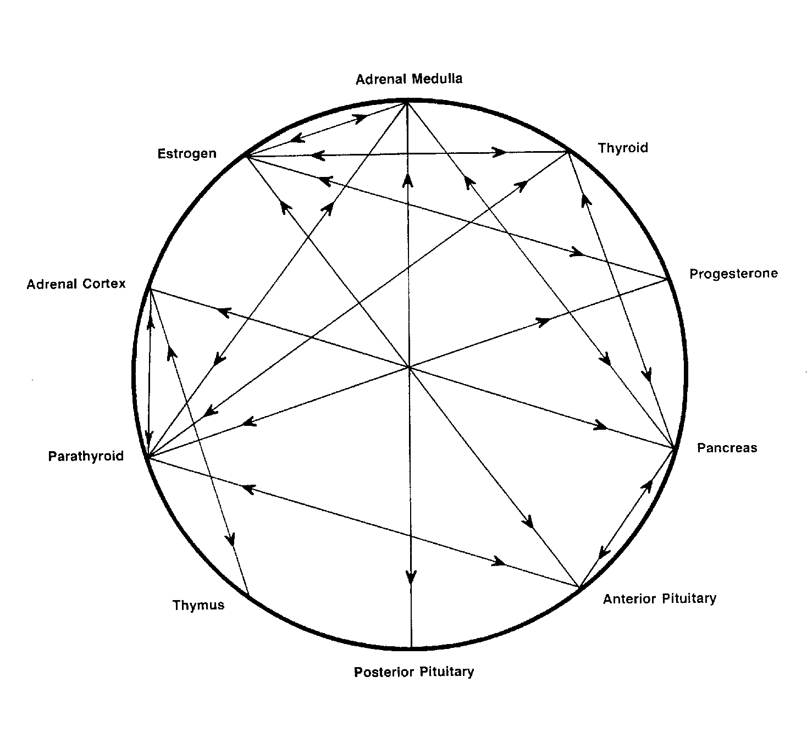
-------------------------------------------------------------------------------------------------------------------------------------------------------
For Further Information, please refer to "Nutrient Interrelationships Minerals - Vitamins - Endocrines, Watts, D.L.,
Journal Of Orthomolecular Medicine, 5, 1, 1990

Copyright 1990 | Trace Elements, Inc. | All rights reserved.
No part of this document may be used or reproduced in any manner whatsoever without the express written permission of Trace Elements, Incorporated. 4501 Sunbelt Drive, Addison, Texas 75001 USA (972) 250-6410.

