

| MAGNESIUM WHEELS

Magnesium is the fourth most abundant cation in the body and is a key element in cellular metabolic functions. Magnesium is responsible for activating over 200 critical enzymes. Due to the extensive role of magnesium in biological processes recognizing its synergistic and antagonistic role with other nutrients is extremely important and can greatly enhance its therapeutic effectiveness in many health conditions.

The following graphics illustrate some of magnesium’s biological antagonistic relationships (arrows indicate antagonistic effect). Prolonged intake of these specific vitamins and/or minerals, singularly or in combination, can produce a magnesium deficiency, especially if the nutritional or tissue magnesium status is already marginal.
Conversely, excessive tissue magnesium or prolonged intake of magnesium can antagonize these same specific vitamins and minerals. It should be noted that antagonism with another nutrient can occur via competition on an absorptive level (intestinal absorption) or metabolic level (cellular), producing compartmental displacement, or increasing requirements.
-------------------------------------------------------------------------------------------------------------------------------------------------------
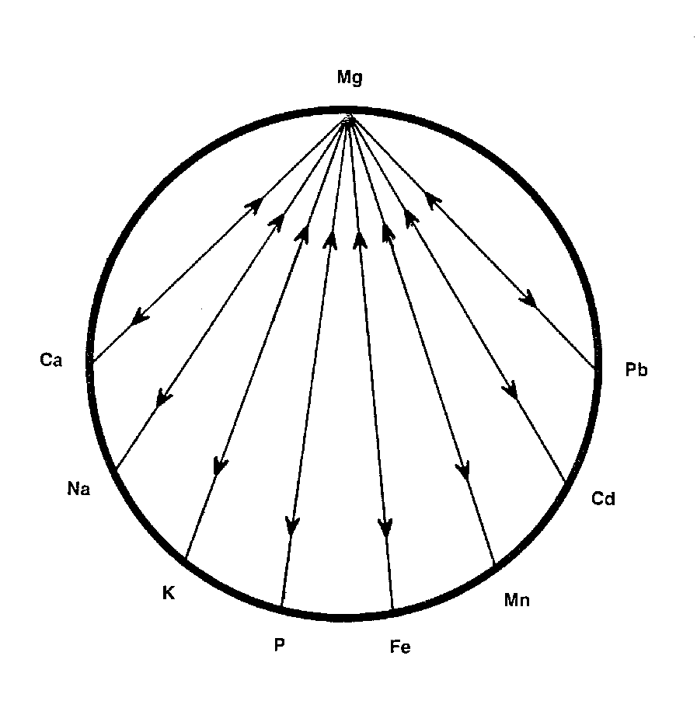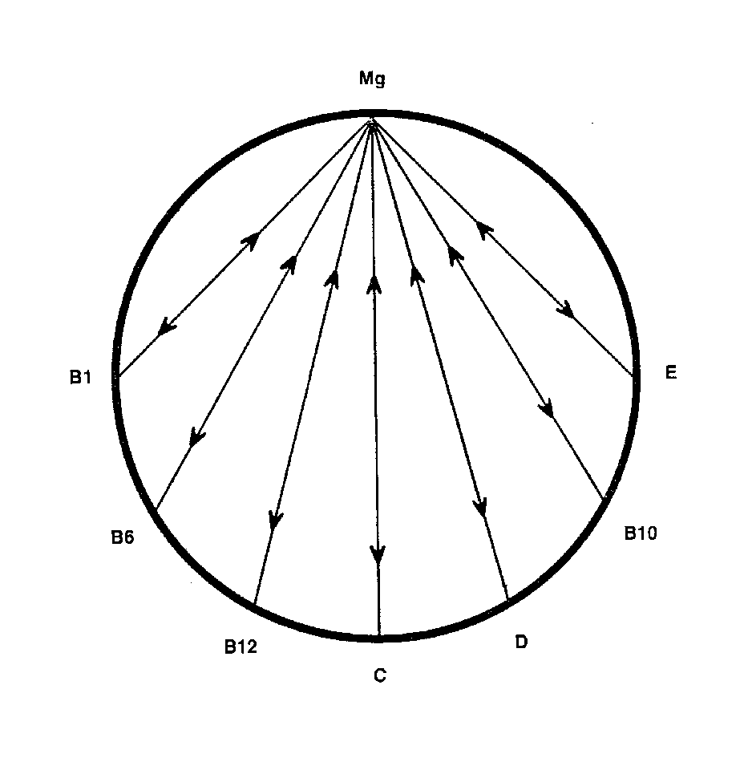
-------------------------------------------------------------------------------------------------------------------------------------------------------
For Further Information, please refer to "The Nutritional Relationships of Magnesium, Watts, D.L., Journal Of Orthomolecular Medicine, 3, 4, 1988

Trace Elements has pioneered the recognition of nutritional interrelationships, and specializes in evaluating individual nutritional requirements through hair tissue mineral profiles.

Copyright 1988 | Trace Elements, Inc. | All rights reserved.
No part of this document may be used or reproduced in any manner whatsoever without the express written permission of Trace Elements, Incorporated. 4501 Sunbelt Drive, Addison, Texas 75001 USA (972) 250-6410.

