

| MANGANESE WHEELS
Manganese is located largely in the mitochondria of the cells. Therefore, the structure and function of mitochondria are particularly affected by manganese status. Manganese is not only responsible for activation of mitochondrial superoxide dismutase, but it also activates enzymes associated with fatty acid metabolism and protein synthesis, which are highly important for normal cellular function.

The following graphics illustrate some of manganese’s biological antagonistic relationships (arrows indicate antagonistic effect). In the case of manganese toxicity, increased intake of these antagonistic vitamins and the nutritional minerals may be of benefit. However, prolonged intake of these specific vitamins and/or minerals, singularly or in combination, can contribute to a manganese deficiency, especially if the nutritional or tissue selenium status is already marginal. Conversely, manganese toxicity or prolonged intake of manganese can antagonize these same vitamins, minerals and heavy metals. It should be noted that antagonism with another nutrient can occur via competition on an absorptive level (intestinal absorption) or metabolic level (cellular), producing compartmental displacement, or increasing requirements.
-------------------------------------------------------------------------------------------------------------------------------------------------------

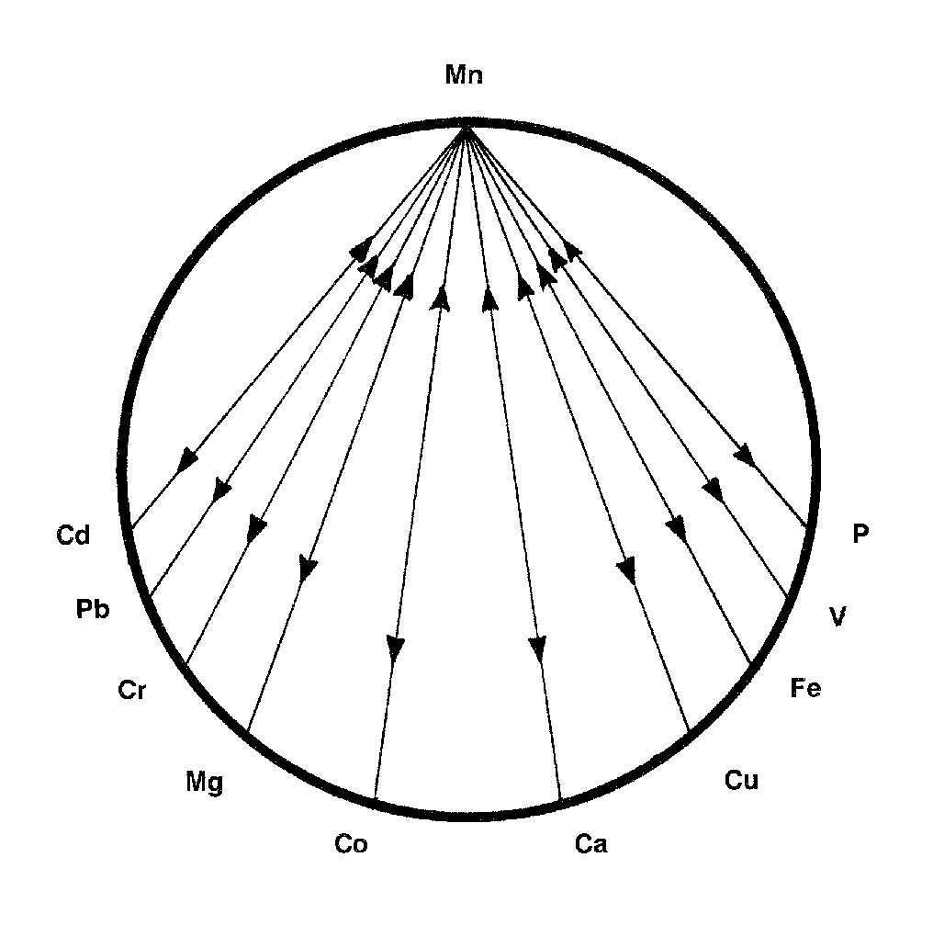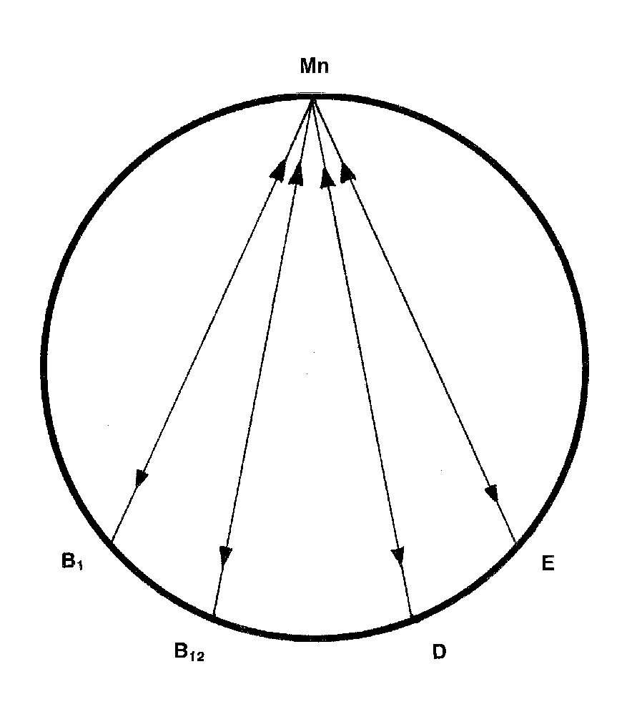

-------------------------------------------------------------------------------------------------------------------------------------------------------
For Further Information, please refer to "The Nutritional Relationships of Manganese, Watts, D.L., Journal Of Orthomolecular Medicine, 5, 4, 1990

Trace Elements has pioneered the recognition of nutritional interrelationships, and specializes in evaluating individual nutritional requirements through hair tissue mineral profiles.

Copyright 1990 | Trace Elements, Inc. | All rights reserved.
No part of this document may be used or reproduced in any manner whatsoever without the express written permission of Trace Elements, Incorporated. 4501 Sunbelt Drive, Addison, Texas 75001 USA (972) 250-6410.

