

| SELENIUM WHEELS
A direct biochemical role for selenium was found in its’ relationship to glutathione peroxidase activity. Selenium’s synergistic relationship to vitamin E found it to be an inhibitor of chemical carcinogens by accelerating their detoxification. Selenium protects against chromosomal damage, stimulates DNA repair and modulates the rate of cell division. Selenium has since been found to play a role in normal thyroid expression and aids in the peripheral conversion of T4 to T3 in the liver and kidneys.

The following graphics illustrate some of selenium’s biological antagonistic relationships (arrows indicate antagonistic effect). In the case of selenium toxicity, increased intake of these antagonistic vitamins and the nutritional minerals may be of benefit. However, prolonged intake of these specific vitamins and/or minerals, singularly or in combination, can contribute to a selenium deficiency, especially if the nutritional or tissue selenium status is already marginal. Conversely, selenium toxicity or prolonged intake of selenium can antagonize these same vitamins, minerals and heavy metals. It should be noted that antagonism with another nutrient can occur via competition on an absorptive level (intestinal absorption) or metabolic level (cellular), producing compartmental displacement, or increasing requirements. Note: Broken lines indicate a suspected antagonistic relationship.
-------------------------------------------------------------------------------------------------------------------------------------------------------

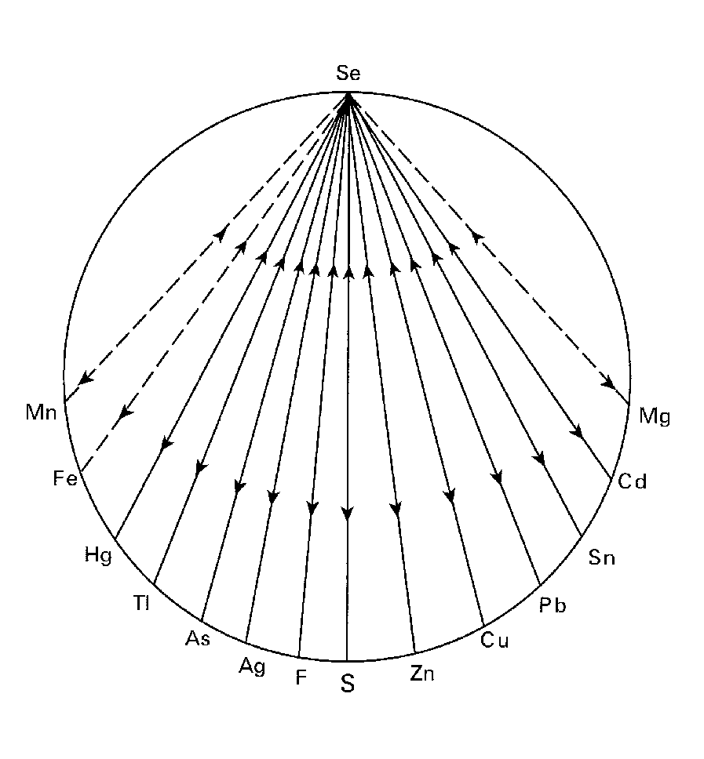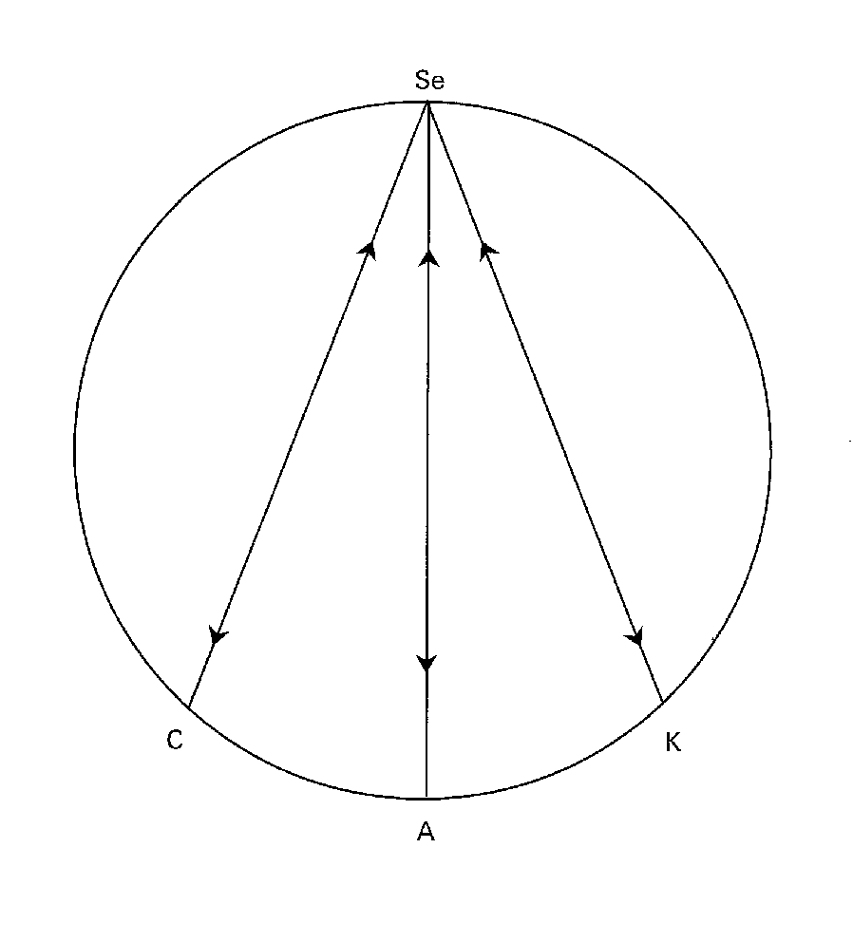
-------------------------------------------------------------------------------------------------------------------------------------------------------
For Further Information, please refer to "The Nutritional Relationships of Selenium, Watts, D.L., Journal Of Orthomolecular Medicine, 9, 2, 1994

Trace Elements has pioneered the recognition of nutritional interrelationships, and specializes in evaluating individual nutritional requirements through hair tissue mineral profiles.

Copyright 1994 | Trace Elements, Inc. | All rights reserved.
No part of this document may be used or reproduced in any manner whatsoever without the express written permission of Trace Elements, Incorporated. 4501 Sunbelt Drive, Addison, Texas 75001 USA (972) 250-6410.

